Leader’s monthly bulletin – October 2023
Welcome to the October edition of my monthly bulletin, which aims to keep councillors, officers, and town and parish councils up to date on the month’s main news stories and any emerging issues from the district. Caroline

St Peters Court
On 3 October, Cabinet took the decision to move tenants into new accommodation prior to demolition of St Peters Court, Lowestoft’s only high-rise accommodation.

The building has been undergoing an extensive improvement programme, and as part of this, a full survey of the building indicated that a further ongoing programme of repair and refurbishment would be required.

The estimates indicate an initial cost of £8,835,088 in year one and an average cost over 30 years of £8,652 per year, per dwelling. This equates to £23,361,239 investment over 30 years to keep the building safe, compliant, and to a habitable standard, based only on today’s building safety regulations and not considering future amendments.

Over the next 30 years the building would generate a deficit of -£2.5m significantly reducing the Council’s ability to invest in the rest of the stock or continue to renew homes.
Comparatively, initial estimates suggest a new build medium-density scheme on the same site could provide a return on investment after 25 years. A regeneration project team will now be created to consider all potential options for the site, and these will be presented to the Cabinet for consideration in due course.

The Council will now begin a managed process, in a carefully planned way to move residents into new accommodation over the next 12 months and then demolish the building.

Our Direction
East Suffolk Council is seeking the views of local people on the direction that it takes for the next four years.

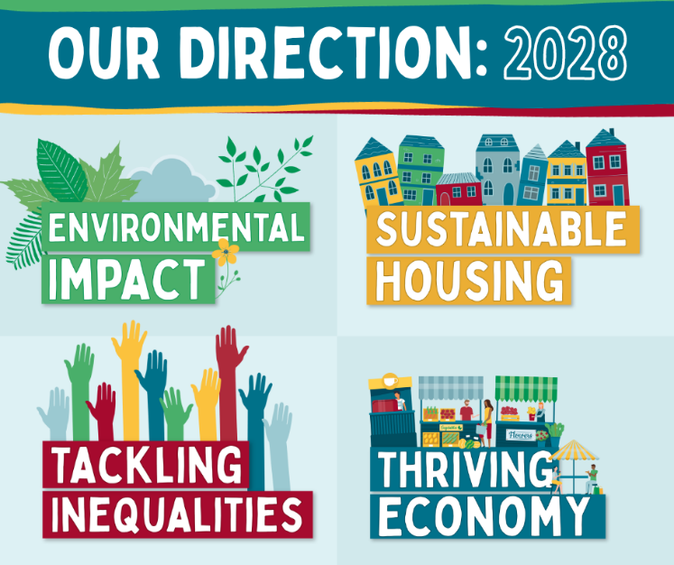
‘Our Direction 2028’ proposes ‘to promote a bright, green, open, free, and fair future for all East Suffolk’ and is accompanied by four key themes which would form the basis of the Council’s approach to service delivery and direction across the next four years. The four themes will be Environmental Impact, Sustainable Housing, Tackling Inequalities, and a Thriving Economy.

A short survey is open and I would encourage you to share this widely.

Responses can be submitted before midnight on Sunday 15 October.

Key infrastructure projects to benefit from £3.4m funding
Over £3million in contributions from new housing developments has been allocated to support the enhancement of community facilities in East Suffolk.

At a meeting of the Cabinet on 5 September, six applications for district Community Infrastructure Levy (CIL) were approved. The successful applications, totalling £3,479,203 were:

- Improvements at Barnards Soccer Centre, Lowestoft (£101,500)
- Extended funding for Foxhall Household Waste and Recycling Centre improvements (£164,500) - in addition to previous funding of £794,414.
- Bungay Medical Practice extension and reconfiguration (£1.283m)
- New 3G pitch at Bungay Town Football Club (£547,803)
- Melton Early Years Provision at Melton Primary School (£1.35m)
- Bungay Library extension (£32,400)
The CIL funding will now be made available to these projects, subject to the provision of all necessary documentation and planning permissions.

New flood defences tested
Lowestoft’s recently completed tidal wall defences, that will reduce the risk of flooding in the town, have been tested in readiness for the winter season.

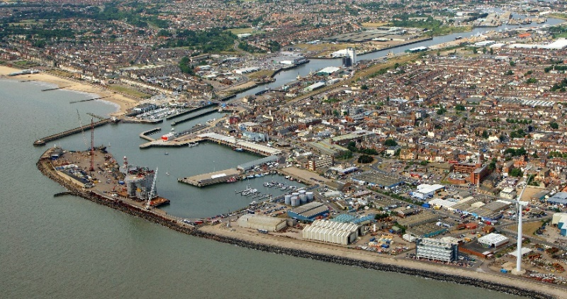
A training exercise took place on 21 September to test the deployment of a section of the new defences and flood gates. The permanent tidal flood defences were used in combination with the existing temporary flood barriers to reduce the risk of flooding to the town.

Every year the emergency response against a tidal surge, such as that which happened in December 2013, is tested and those operating the barriers are put through their paces to ensure that East Suffolk Council can provide the best possible response to the threat of a further North Sea tidal surge.

Disappointment with Prime Minister’s decision
Earlier this month, I expressed my disappointment with the Prime Minister’s decision to postpone several key environmental commitments. Read my full statement.

Designs revealed for Cultural Quarter
As part of a major programme to reinvigorate Lowestoft’s town centre, proposed designs for improvements in the Marina area have been made available.

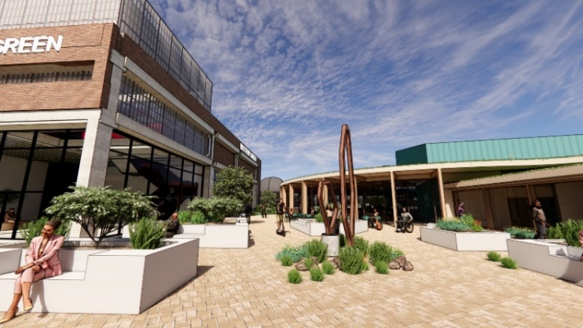
The Cultural Quarter project is one of five transformational regeneration projects which received £24.9m from the Government’s Towns Fund last year and will see the redevelopment of the Council’s current Customer Services Centre and the former Battery Green multi-storey car park.

The development will provide a new cultural and community hub with studio space for creative businesses together with a competitive leisure complex and restaurant.

Working closely with East Suffolk Council, Norwich-based architects Chaplin Farrant in partnership with HemingwayDesign have developed designs in readiness for a planning application to be submitted.

Council calls for assurance on energy infrastructure projects
East Suffolk Council has strengthened its commitment to ensuring the best possible outcomes and minimal impact for local communities from the construction of Sizewell C.

The renewed pledge comes with an expectation of developers, in conjunction with all stakeholders, to identify long-term solutions to a number of key issues. Read more

Offering a Warm Welcome to residents in need
In September, voluntary organisations and community groups in East Suffolk were invited to apply for funding to become a Warm Welcomes (formerly Warm Rooms) venue.

Warm Welcomes provide a safe, warm and welcoming space where members of the community, including people who may be struggling with the cost of heating their homes, can come to meet with others and access information about additional support.

Funding applications will be considered by a panel and once confirmed, a list of all the Warm Welcomes will be made available online.

Wickham Market residents to vote on Neighbourhood Plan
Residents in Wickham Market will be invited to vote in a referendum on Thursday 12 October to decide whether the Neighbourhood Plan for their area should be used to determine future planning applications.

The Wickham Market Neighbourhood Plan was prepared by Wickham Market Parish Council and contains a vision for the future of Wickham Market and sets out clear planning policies to 2036.

Providing support for faith groups
Representatives from faith groups across East Suffolk are invited to a free ‘Faith in Partnership’ event at East Suffolk House on Tuesday 10 October (9.30am - 3pm). The event aims to build relationships between faith groups, statutory agencies and the voluntary sector to benefit local communities.

The event will enable faith groups to find out more about data collected on community needs, funding opportunities, volunteering, advice on setting up projects and working in partnership with other services, as well as offering a platform to feedback on what additional support is required.

Consultations
Views invited on permit for small waste incineration plant
An application for an environmental permit has been submitted to East Suffolk Council for a small waste incineration plant at Ellough, near Beccles and residents are invited to submit their views.

The proposal to build and operate a Small Waste Incineration Plant (SWIP) in Ellough was submitted to Suffolk County Council and planning permission was granted in May 2023. This plant will be owned, constructed and managed by V.C. Cooke Ltd alongside their existing waste operation on the Ellough Industrial Estate.

In law, as well as planning permission for a waste incinerator, the operators need to obtain a permit to ensure it operates with minimal pollution. V.C. Cooke Ltd have now applied to East Suffolk Council for this permit, and provided information about how the site will be built and controlled.

Residents are invited to take part in the consultation and provide any information about the site that may not be included in the application paperwork. The consultation closes on 5 November.

Comment on renewal of PSPOs
Residents are invited to have their say on the proposed renewal of three Public Space Protection Orders (PSPOs) which are due to expire early next year.
Adopted in 2021, the three PSPOs are being proposed for renewal without any alteration to existing restrictions for a further three years. The PSPOs cover areas including Aldeburgh Beach and Landguard Point Nature Reserve in Felixstowe, as well as the general requirement for keeping dogs on leads in specific areas.
A consultation is open until 13 November, inviting people to give their views on the proposed renewals.
Comments invited on new planning document
A consultation is currently underway inviting views on the draft Custom and Self-build Housing Supplementary Planning Document (SPD), which provides guidance on the development of custom and self-build housing.

The draft SPD covers a range of topics including the types of housing that qualify as custom and self-build housing, an overview of the self-build exemption from Community Infrastructure Levy, consideration of design and the application of design codes, and guidance to help ensure custom and self-build housing is appropriately marketed.

The consultation ends on 18 October.

Polling station review
To ensure they remain suitable for voters, polling stations and polling districts in East Suffolk are currently being reviewed and residents are invited to comment before 30 November.

The ‘Polling Districts and Polling Places’ review aims to ensure that the current polling districts, polling places and polling stations in East Suffolk are suitable and convenient for electors, and to assess feedback from voters or other interested parties.

Stay up to date with the latest East Suffolk news!
The Communications Team shares all media coverage on SharePoint, so you can easily stay up to date on all media stories relevant to East Suffolk Council, whether on local, regional or national news outlets, tv, radio, print or online.
We do a lot of great work in East Suffolk, and we want everyone to know! I would therefore like to encourage all Councillors to share their own good news stories with the Communications Team so they can help showcase some of this work, whether this is from projects funded through your Enabling Communities Budget or supporting an initiative which will benefit our local communities.
We keep our communities up to date in a variety of ways and social media has an important role to play. Please follow us and share our posts with your audiences.
Facebook Twitter Instagram
If you have any questions or need any help with communications and promotion, you can email the team on communications@eastsuffolk.gov.uk

Diary dates
- 10 October at 2pm - Planning Committee North (Conference Room, Riverside)
- 16 October at 6pm - Beccles, Bungay, Halesworth and villages Community Partnership (Bungay Community Support)
- 16 October at 6.30pm - Licensing Committee (Conference Room, Riverside)
- 18 October at 6pm - Carlton Colville, Kessingland, Southwold and villages Community Partnership (Kessingland Parish Council offices)
- 19 October at 6.30pm - Scrutiny Committee (Conference Room, Riverside)
- 23 October at 10.15am - Licensing Sub-Committee (Deben Conference Room, East Suffolk House)
- 24 October at 2pm - Planning Committee South (Deben Conference Room, East Suffolk House)
- 26 October at 10.15am - Licensing Sub-Committee (Conference Room, Riverside)

