Framlingham Ward - Brief update for September / October 2023
District Councillor - Vince Langdon-Morris
Following the traditional August holiday break, work routines and council meetings have vigorously re-established themselves in September!
Framlingham News
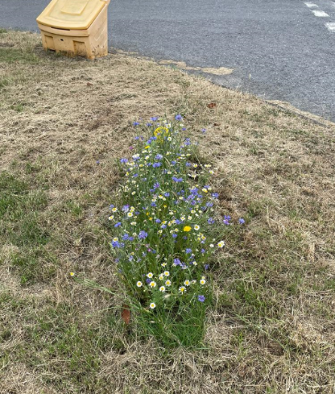
Wildflowers Sites: Following the successful establishment of several small wildflower sites this spring, The Swift and Wildlife Group have received permission from East Suffolk Council to establish three new, small wildflower sites on the grassed areas of Castle Brooks Park and Mowbrays. They also hope to establish a small area fronting Mills Meadow. All these sites will be set away from the beaten path and if successful will hopefully be expanded in 2024 🙂
Framlingham Town Council has re-established a Sustainable Framlingham Group with four themes: reducing our CO2 emissions footprint; biodiversity enhancement (making space for nature to sustain life); least trace living (reducing waste and increasing re-use) and resilience to climate change. I look forward to working closely with this group in the future.
Barclays Pop Up Bank: Has been established in the Crown Hotel in the town square. The service is open Mon to Wed, 9am to 5pm and closed for lunch between 12.30 to 1.30pm and then on Thursday 9am to 12.30pm. Please do use this service if you can, to ensure we maintain a bank presence in the town. Note that the Post Office also offers banking services, can provide cash and the Coop can also do cash-back.
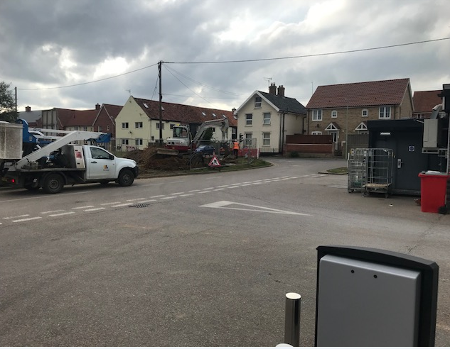
Housing: In September I submitted a motion for debate at ‘full’ ES council, asking that outline planning permission for Victoria Mill Road be withdrawn and reviewed (it’s still with the Secretary of State, the developer is asking to expand house construction from 35 to 49). The East Suffolk Council Legal team reviewed this and declared it illegal and therefore not debatable (only the recipient of outline planning permission can withdraw an application). My opinion remains that Framlingham has fully achieved its housing targets (as clearly set out in the Suffolk Coastal Local Plan). What is needed is investment in infrastructure, more especially ongoing water pollution.
Construction: Residents will have noticed construction and temporary traffic lights in Station Road (at the Co-op garage, see pic). I spoke with the construction crew and it is a rebuilt manhole and drainage pipe linked to the nearby River Ore. I want to find out why this is being done and why our Town Council was not informed that this was going to take place?
Other Parish news:
Brandeston: As Radio 4 listeners know, pubs have been in the news. In Brandeston, the Queen pub was sold and some reconstruction has now taken place? The premises were recently visited by an East Suffolk Council enforcement officer, I will hopefully give feedback in my next update.
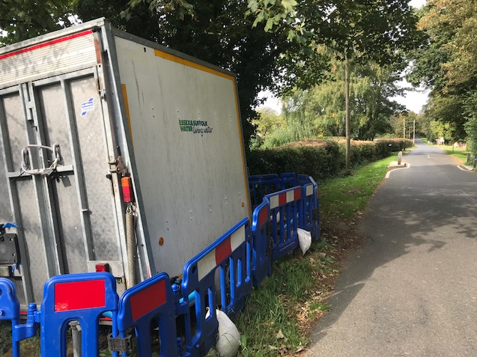
Saxstead & Easton: In Saxtead, over the past 14 months residents have had to contend with between 240-250 deliveries of HGV tankered water, pumped into the nearby Dennington water tower.
In April 2023, Easton had a large diesel water pump set-up in Framlingham Road (see pic) on the verge outside residences (apparently operating 24/7). Here is a recent picture of the current set-up pumping water to Framlingham? I will hopefully give more feedback in my next update.
Cretingham: ESC Planning recently awarded a retrospective commercial use licence for Corner Farm outbuildings. I support this as it drives more economic activity and jobs. However I would also like to state that there are rules and regulations that must be followed by licence holders, especially in a small, quiet village.
There are numerous planning applications going on across East Suffolk and our ward is no exception. I will try and keep you abreast of the ones of which I am most familiar.
Finally, The Katch Bus. Please do consider using the Katch bus, you can either visit www.katchalift.com for information or download the Flexiroute Passenger App.

