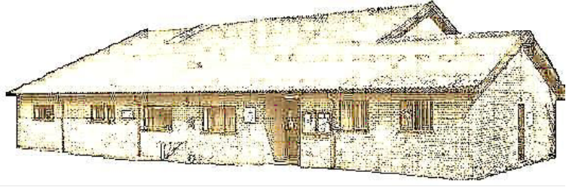

Dennington Jubilee Hall, c/o Red House Farm, Dennington, Woodbridge, Suffolk. IP13 8AQ
Email; jambomabs@gmail.com Tel. 01728 638627 Mob. 07885 976538

Report for Dennington Village hall to the Parish Council

18/05/2015

I took over as chairman after David Dunnett decided he had done enough time as chairman. He has done excellent work over a number of years and continues to be the treasurer and runs the bar. Thanks very much to David and his wife Linda for their tireless efforts.

The Village Hall is used on a reasonably regular basis by a number of local users which include:- WI, Sports Club, Badminton Club, Parish Council, Chamber Orchestra and the Rabbit Club.

The 100 club continues to add extra income to our funds and is fully subscribed at the moment. Many thanks to Jenny Dyne and her collectors for keeping this going.

The coffee morning, started by Binkie Andrews and Maggie Archard has been a resounding success. We now need to build on that for the future.

Many thanks to everybody that has helped in many different ways around the hall, but I particularly wish to mention Ian Mann for trimming the bushes and grass unasked and Ricky Robinson for his constant and regular quiet repainting and maintenance programme.

In the last 5 years, the income of the Hall has dropped by 60%. Upo until 31st march, income was £6082.00 with expenditure £5423.00. thus a miniscule profit. Obviously due to many factors, but to draw people back into the Hall, we need to refurbish it somewhat.

The Creative Committee have proposed some serious refurbishment is required to bring the Hall back to being a facility the village can be proud of. We aim to ensure it is both attractive and functional and that the refurbishment will be good for another 25 years. We are holding a meeting on Thursday to present these to the full body of Trustees for approval.

In brief, we aim to refurbish the following:

Phase 1

a) The Road entrance. The entrance itself is currently breaking up and needs serious attention. It will include repair of the culvert and the installation of an aco drain to drain off as much water as possible before it reaches the car park. Cost £4,900.00

Hall entrance foyer. The laying down of a mock-wood Amtico floor in the main foyer, stretching through to the kitchen door. This would greatly enhance the visual entrance to the Hall. Extremely durable, this will last much longer than a real wood floor. Cost £1000.00

b) ) A hung ceiling in the main hall. This would be at 4.2m high to accommodate badminton, fully insulated and with sides sloping down. Walls raised with plasterboard (also with insulation) making it look more like a room than a barn. Cost £8000.00

c) Heating in the main hall and bar area - new Toshiba air to air heaters with fans which would be installed in the hung ceiling above. It would also include heating for the bar area.

Cost £18,760.00

d) The kitchen area – Widening of the kitchen area by removing the wall between the kitchen and kitchenette, the revamping of the kitchen serving ‘window’ and the installation of 2 regular cookers to replace the old one. Guide cost £15,000.00

Phase 2

A porch. The porch would make a massive visual difference to the Hall entrance.

This would also include the laying of a French drain along the side of the hall to catch any water running off the road and car park. Guide cost £9,300.00

f) Roof cleaning/painting; A quote for £800 to clean the hall roof so it looks good, and an additional £1600 for two coats of bitumen paint (colour to be decided).

Cost £2,400.00

g) A patio. This would be situated on the sports field side of the building offering those watching sport a pleasant facility to enjoy a drink in relative comfort.

Cost £9,500.00

Fundraising

We intend to approach a number of organisations to raise funds for these projects. We have so far been offered “up to £4000.00” by Stephen Burroughes, our local County Councillor, though this is likely to be a moving target.

Dennington Charities have donated £5000.00 to the Hall to help get these projects underway.

We will establish a couple of application writers over the coming months and set to work. We will also be holding a number of functions to raise funds ourselves locally.

Local produce days (Saturdays?) Allotments?

Bar nights on Wednesday and Friday nights

Many more evenings. Dances, curry nights, reading club sports evenings etc etc.

Dennington Newsletter - sponsored by Village Hall and Sports Club

The first edition of this will be out in June. Sally O’Keeffe is the editor. Ist edition will be 8 pages of A5 – brief – the next will be fuller.

Conclusion

A real momentum is developing at present in relation to the Hall. Through the newsletter, and at a presentation to the village in September, we hope to re-ignite a sense of ‘ownership’ in our own unique facility. We hope that all of you will take that on board and will become part of its future. We intend to establish a series of activities throughout the year which are of real interest which will assist in bringing in funds, so any ideas are welcome.

James Maberly

Chairman of Trustees

